**Dan Schumacher**

**Hdd249**

DA 6823

Kilger

Module 3: Part #2 (15 points)

**Dependent Samples t test**

Here is the SAS printout for a dependent samples ttest that compares advertising receptivity (scale = person has low ad receptivity, 5=person has high ad receptivity) before and after the person drinks a shot of tequila.

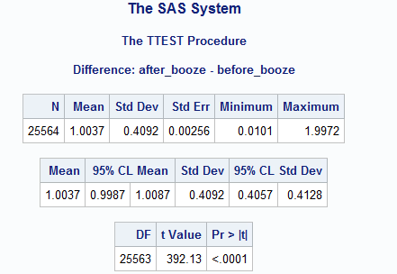

1. State the null and alternative hypotheses for the dependent sample t test. (4 points)
   1. **H0: The mean difference of tequila drinkers ad-receptivity and the non-drinkers == 0**
   2. **Halt: The mean difference is not 0.**
2. Name one assumption of the dependent sample t test (2 points)
   1. **The data is normally distributed.**
3. What is the difference in the before and after alcohol means? (2 points)
   1. **The mean difference is 1.0037.**
4. What can you conclude about the change in advertising receptivity due to the application of alcohol to a respondent? (4 points)
   1. **With a p value of less than .0001, we can reject the null hypothesis. This test suggests that the mean difference between tequila and sober ad-receptivity is not 0.**
5. Why is this called a “paired” or dependent sample t test? (3 points)
   1. **It is called paired/dependent because everyone must be present in both test groups. For our purposes it means that a person got a score with tequila, then *that same person* got another score without tequila. Therefore, those scores are *dependent* on each other.**